**Some Captures from the Tool**

1. Choose the YouTube Channels to Analyze. I selected these three as an example

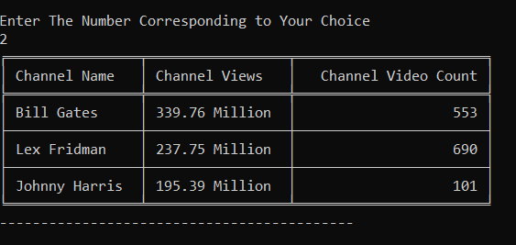

Analyze a single channel

Get information about each video

Zoom in and pan around the graph

Original

Zoom In

Zoom In even more

Analyze Multiple Channels Together

